REPUBLIC OF CAMEROON
Peace – Work – Fatherland
MINISTRY OF HIGHER EDUCATION
SHIBMATS
(Salvation Higher Institute of Biomedical, Management and Technology Sciences)

INTERNSHIP REPORT
THEME:

DESIGN AND IMPLEMENTATION OF A LOCALLYHOSTED STUDENT MANAGEMENT SYSTEM
("STUDENT HUB")
Submitted in partial fulfillment of the requirements for the award of the Higher National Diploma (HND) in Software Engineering
By: MERIKI JUBERT
(HND Year 2 Student)
Academic Supervisor:  Madam Tabi Lizzy | Field Supervisor:  Mr. Kwanyuy Daniel Vernyuy
Academic Year: 2024/2025

CERTIFICATION
This is to certify that the internship report titled "DESIGN AND IMPLEMENTATION OF A LOCALLY-HOSTED STUDENT MANAGEMENT SYSTEM (STUDENT HUB)" is the original work carried out by MERIKI JUBERT, a Level 200 student of the Department of Software Engineering at SHIBMATS.

This work was conducted at the Digital Development Center (DDC), Buea, from 1st February to 1st March 2025, in partial fulfillment of the requirements for the award of the Higher National Diploma (HND) in Software Engineering.

Field Supervisor  Mr. Kwanyuy Daniel Vernyuy  Technical Director, DDC | Academic Supervisor  Madam Tabi Lizzy  SHIBMATS Faculty
__________________________
Head of Department

DEDICATION
To my beloved family, for your endless love, prayers, sacrifices, and unwavering support throughout my academic journey.

ACKNOWLEDGEMENTS
My profound gratitude goes first to the Almighty God for His grace, wisdom, and protection throughout the duration of my internship and the compilation of this report.
I wish to express my sincere appreciation to the administration of SHIBMATS for providing the academic platform that has nurtured my professional growth. Special thanks to the Head of the Software Engineering Department for their guidance.
My deep gratitude goes to the management of the Digital Development Center (DDC), particularly the CEO, Mr. Kome Emmanuel N., for accepting me into their esteemed institution. I am especially grateful to my field supervisor, Mr. Kwanyuy Daniel Vernyuy (Technical Director), for his technical mentorship, and to Ms. Tabi Lizzy (Monitoring & Evaluation) for her constant administrative support and guidance during my stay.
I also acknowledge the Logistics Manager, Mr. Epiengande Daiel, and the Safety Manager, Mr. Modika William W., for ensuring a conducive working environment.
Finally, heartfelt thanks to my parents, siblings, and friends for their financial and moral support, which was instrumental in the success of this work.

ABSTRACT
This report details the internship activities undertaken at the Digital Development Center (DDC) in Buea from February 1st to March 1st, 2025, as a partial requirement for the Higher National Diploma in Software Engineering. The primary objective of this internship was to bridge the gap between theoretical academic knowledge and practical industrial application.
During this period, I was involved in various technical activities ranging from networking fundamentals and Scrum agile methodologies to full-stack web development. The core focus of my internship was the design and implementation of a project titled "Student Hub"—a locally-hosted Student
Management System. This system was developed to address the challenges of manual record-keeping and the high cost of existing digital solutions for small educational institutions.
The "Student Hub" was built using HTML, CSS, and JavaScript for the frontend, with a robust backend powered by Node.js and Express.js, and SQLite for offline data management. Key features implemented include a three-tier Role-Based Access Control (RBAC) system for students, teachers, and administrators; a CRUD system for grade and course management; automatic GPA calculation weighted by course credit hours; a department management module; a dynamic student enrollment system; LAN-based multi-device access without internet connectivity; and a secure student feedback mechanism. The project successfully demonstrated that a lightweight, offline-first architecture can effectively manage academic records while ensuring data privacy and reducing operational costs.

RÉSUMÉ
Ce rapport détaille les activités de stage entreprises au Digital Development Center (DDC) à Buea du 1er février au 1er mars 2025, dans le cadre de l'obtention du Higher National Diploma (HND) en Génie Logiciel. L'objectif principal de ce stage était de combler le fossé entre les connaissances théoriques académiques et l'application industrielle pratique.
Au cours de cette période, j'ai participé à diverses activités techniques allant des principes fondamentaux des réseaux et des méthodologies agiles Scrum au développement web full-stack. Le cœur de mon stage a été la conception et la mise en œuvre d'un projet intitulé "Student Hub" — un système de gestion des étudiants hébergé localement. Ce système a été développé pour répondre aux défis de la tenue manuelle des dossiers et au coût élevé des solutions numériques existantes pour les petits établissements d'enseignement.
Le "Student Hub" a été construit en utilisant HTML, CSS et JavaScript pour le frontend, avec un backend robuste propulsé par Node.js et Express.js, et SQLite pour la gestion des données hors ligne. Les fonctionnalités clés mises en œuvre comprennent le contrôle d'accès basé sur les rôles (RBAC) pour les étudiants et les enseignants, un système CRUD (Créer, Lire, Mettre à jour, Supprimer) pour la gestion des notes, et un mécanisme de feedback sécurisé. Le projet a démontré avec succès qu'une architecture légère et hors ligne peut gérer efficacement les dossiers académiques tout en garantissant la confidentialité des données et en réduisant les coûts opérationnels.

Contents
INTERNSHIP REPORT 1
DESIGN AND IMPLEMENTATION OF A LOCALLYHOSTED STUDENT MANAGEMENT SYSTEM 1
CERTIFICATION 2
DEDICATION 3
ACKNOWLEDGEMENTS 4
ABSTRACT 5
RÉSUMÉ 6
PREFACE 7
GENERAL INTRODUCTION 11
CHAPTER 1: PRESENTATION OF DDC & INTERNSHIP ACTIVITIES 14
CHAPTER 2: OVERVIEW OF THE TOPIC STUDIED 18
PART TWO: PROJECT FRAMEWORK 20
CHAPTER 3: DIAGNOSTIC OF THE EXISTING SYSTEM 20
CHAPTER 4: DESIGN & IMPLEMENTATION OF THE PROPOSED SYSTEM 21
GENERAL CONCLUSION 31
BIBLIOGRAPHY 32

PREFACE

The Higher National Diploma (HND) program in Cameroon is designed to produce professionals who are not only theoretically sound but also practically competent. To achieve this, the Ministry of Higher Education mandates a period of industrial attachment (internship) for all students before graduation. This internship provides students with the unique opportunity to experience the professional work environment, understand organizational culture, and apply classroom concepts to solve real-world problems.
This report is a comprehensive documentation of my one-month internship at the Digital Development Center (DDC). It serves as evidence of the skills acquired, the challenges faced, and the solutions provided during this period. The report is structured to reflect both the organizational learning and the technical project implementation, specifically focusing on the development of the "Student Hub" software solution.
Through this document, I aim to showcase the transformation from a student to a budding software engineer, highlighting the technical proficiency gained in web technologies, database management, and systems design.

IDENTIFICATION FORM
 | STUDENT INFORMATION
Name |  | Meriki Jubert
Institution |  | SHIBMATS
Department |  | Software Engineering
Level |  | HND Year 2 (Final Year)
 | COMPANY INFORMATION
Company Name |  | Digital Development Center (DDC)
Location |  | Checkpoint, Buea, South West Region, Cameroon
Year Established |  | 2022
CEO / Founder |  | Mr. Kome Emmanuel N.
Field Supervisor |  | Mr. Kwanyuy Daniel Vernyuy (Technical Director)
 | INTERNSHIP DETAILS
Duration |  | 1 Month (4 Weeks)
Start Date |  | 1st February 2025
End Date |  | 1st March 2025
Project Theme |  | Design and Implementation of "Student Hub" System

LIST OF ABBREVIATIONS
Abbreviation | Full Meaning
API | Application Programming Interface
CRUD | Create, Read, Update, Delete
CSS | Cascading Style Sheets
DB | Database
DDC | Digital Development Center
GPA | Grade Point Average
ERD | Entity Relationship Diagram
HND | Higher National Diploma
HTML | Hypertext Markup Language
HTTP | Hypertext Transfer Protocol
JS | JavaScript
NPM | Node Package Manager
RBAC | Role-Based Access Control
SHIBMATS | Salvation Higher Institute of Biomedical, Management and Technology Sciences Studies
SIS | Student Information System
SMS | Student Management System
SQL | Structured Query Language
SQLite | Structured Query Language Lite (lightweight relational database)

UAT | User Acceptance Testing
LAN | Local Area Network
QR | Quick Response (Code)
UI/UX | User Interface / User Experience
UML | Unified Modeling Language
URL | Uniform Resource Locator

LIST OF FIGURES
Figure | Description | Page
Figure 1 | High-Level System Architecture of Student Hub | 19
Figure 2 | Use Case Diagram – Student Hub System | 20
Figure 3 | Class Diagram – Student Hub System | 21
Figure 4 | Sequence Diagram – Login and Authentication Flow | 22
Figure 5 | Entity Relationship Diagram (ERD) – Database Schema | 23
Figure 6 | DDC Organizational Chart | 6
Figure 7 | Student Dashboard – UI/UX Wireframe | 26
Figure 8 | Teacher Dashboard – UI/UX Wireframe | 27

GENERAL INTRODUCTION
Contextualization
In the digital age, data is the lifeblood of any educational institution. From enrollment figures to academic performance records, schools generate massive amounts of information daily. However, managing this data remains a significant challenge for many small to medium-sized institutions in Cameroon. Traditionally, student records have been maintained using physical files, paper registers, and disjointed spreadsheet documents. While these methods served their purpose in the past, they are increasingly becoming obsolete due to inefficiencies, susceptibility to damage, and difficulty in data retrieval.
Problem Statement
Despite the availability of modern enterprise software, many local schools still rely on manual record-keeping because commercial solutions are often too expensive, overly complex, or require constant internet connectivity, which is not always reliable. Manual systems lead to data redundancy, loss of academic records due to physical damage (fire, water, pests), and significant delays when generating student transcripts. There is a critical lack of affordable, lightweight, and offline-capable digital tools tailored for resource-constrained environments.
Research Questions
This project seeks to answer the following questions:
How can we digitize student record management for schools with limited internet access?
What architecture is best suited for a lightweight, cost-effective student management system?
How can Role-Based Access Control (RBAC) be implemented to ensure data privacy and appropriate system access among students, teachers, and administrators?
Objectives
The main objective of this internship was to design and implement "Student Hub", a locally-hosted web application for managing student data. Specific objectives included:
To analyze the shortcomings of existing manual systems.
To design a secure database schema using SQLite for efficient local storage. To develop a user-friendly interface using HTML, CSS, and JavaScript.
To implement a secure backend using Node.js and Express.js with rolebased authentication.
Plan of the Report
This report is divided into two main parts. Part One focuses on the internship framework, detailing the host company (DDC) and the activities carried out during the month. Part Two delves into the technical project framework, covering the analysis, design, and implementation of the "Student Hub" system, followed by a general conclusion and bibliography.

LIST OF TABLES
Table | Description | Page
Table 1 | Identification Form – Student and Internship Details | iv
Table 2 | List of Abbreviations and Their Meanings | v
Table 3 | DDC Organizational Structure – Roles and Responsibilities | 7
Table 4 | StudentHub Database Schema – Table Names, Key Fields and Purpose | 24

LIST OF APPENDICES
Appendix | Description | Page
Appendix A | System Screenshots – Student Hub Web Application
Appendix B | Internship Acceptance Letter from DDC
Appendix C | Source Code Structure – StudentHub Project File Tree

PART ONE: THE INTERNSHIP FRAMEWORK

CHAPTER 1: PRESENTATION OF DDC & INTERNSHIP ACTIVITIES

1.1 Presentation of the Company

1.1.1 History and Background
The Digital Development Center (DDC) is a dynamic IT contracting company established in 2022. It was created with the vision of supporting the digital transformation agenda in Cameroon by equipping students and professionals with necessary digital skills. The center aims to foster technology-based solutions to local challenges through software development, training, and consultancy. A significant milestone for the organization was the opening of its dedicated center at the University of Buea on November 26, 2024.

1.1.2 Services Offered
DDC offers a wide range of technological services, including:
Software Development: Custom web and mobile application development for clients.
IT Contracting: Providing technical expertise and staff augmentation for projects.
Digital Literacy Training: Courses on networking, programming, and office productivity tools.
Networking & Hardware Maintenance: Network configuration, router setup, and hardware repair.
Project Collaboration: Partnering with academic institutions for student research and internships.

1.1.3 Organizational Structure
The company is led by a streamlined management team ensuring efficient operations across all departments. The organizational hierarchy is as follows:
Role / Position | Name | Responsibilities
CEO & Founder | Mr. Kome  Emmanuel N. | Overall strategic leadership and vision of DDC
Technical Director | Mr. Kwanyuy  Daniel Vernyuy | Oversees all technical projects and engineering teams
Monitoring & Evaluation  (Secretariat) | Ms. Tabi Lizzy | Project quality control, administrative support, intern supervision
Logistics Manager | Mr. Epiengande  Daiel | Coordinates operational logistics and procurement
Safety Manager | Mr. Modika William W. | Ensures workplace safety and compliance
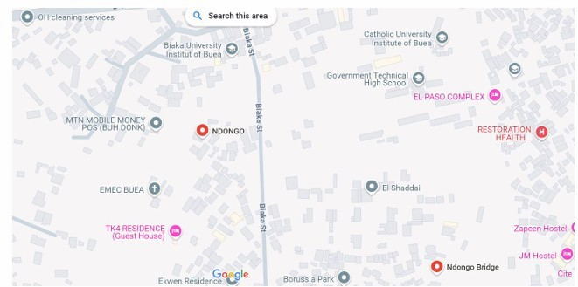Figure 6: DDC Location
1.2 Weekly Internship Activities
The internship spanned four weeks from February 1st to March 1st, 2025. Below is a detailed account of the activities undertaken.

Week 1 (Feb 1 – Feb 7): Orientation and Fundamentals
The first week began with a general orientation led by Ms. Tabi Lizzy, where interns were introduced to the company's rules, safety protocols, and operational ethics. The technical sessions commenced with a refresher on Networking Fundamentals, covering IP addressing, TCP/IP models, and router configurations. We were also introduced to the Scrum Agile Methodology, learning about roles (Product Owner, Scrum Master), artifacts, and sprint planning, which prepared us for collaborative project work. Additionally, we set up our development environments, installing Node.js and Git, and learned version control basics using GitHub.

Week 2 (Feb 8 – Feb 14): Backend Development Training
This week focused heavily on server-side programming. Under the supervision of Mr. Kwanyuy Daniel, we delved into Node.js and Express.js. We learned how to initialize a Node project, manage packages with NPM, and create basic servers. A significant portion of the week was dedicated to Database Management. We explored the differences between SQL and NoSQL, eventually selecting SQLite for our project due to its serverless, zero-configuration nature. We practiced creating tables, running SQL queries, and connecting the database to our Node.js backend.

Week 3 (Feb 15 – Feb 21): Project Design & Frontend Implementation
The third week was dedicated to the "Student Hub" project. We started by designing the system architecture, creating Class Diagrams and Use-Case diagrams to map out user interactions. I utilized Canva to design UI wireframes, ensuring a user-friendly experience. We then moved to coding the frontend using HTML, CSS, and JavaScript. I implemented the login interface and the distinct dashboard layouts for Students and Teachers. Key focus was placed on responsive design to ensure the system was accessible on various devices.

Week 4 (Feb 22 – Mar 1): System Integration & Testing
The final week involved connecting the frontend to the backend. I implemented the CRUD (Create, Read, Update, Delete) functionality, allowing teachers to input and modify student grades. We integrated the feedback system, enabling students to send complaints directly to the database. The week concluded with rigorous testing—checking for broken links, validating form inputs, and ensuring the session management worked correctly for different user roles. Finally, I compiled my findings and presented the working prototype to the supervisor.
1.3 Choice and Justification of Research Topic
The choice to develop "Student Hub" was influenced by the observation that many small educational institutes in Cameroon lack affordable digital tools. While learning about database management at DDC, I realized that a lightweight, locally-hosted solution could solve significant administrative headaches without requiring expensive cloud infrastructure. This project allowed me to apply my skills in full-stack JavaScript development practically.

CHAPTER 2: OVERVIEW OF THE TOPIC STUDIED

2.1 Definition of Student Management Systems (SMS)
A Student Management System (SMS), also known as a Student Information System (SIS), is a software application for educational establishments to manage student data. It integrates students, parents, teachers, and administration into a single platform. Core functions typically include handling inquiries, admission processing, student record maintenance, attendance tracking, and grading.
2.2 Existing Solutions and Limitations
Several commercial solutions exist in the market, such as PowerSchool, Blackboard, and OpenSIS. However, these systems present challenges for the local context:
High Cost: Licensing fees are often prohibitive for small private schools.
Complexity: They offer hundreds of features that small schools do not need, making them difficult to learn and use.
Internet Dependency: Most are cloud-based, rendering them useless during internet outages, which are common in some regions.
2.3 The Need for "Student Hub"
"Student Hub" was conceived to fill this gap. It is designed to be:
Offline-First: Runs entirely on a local network or a single computer without internet.
Lightweight: Uses SQLite, requiring no complex database server installation.
Focused: Provides the essential academic features — Grades, GPA Calculation, Feedback, Department Management, and Role-Based Access Control — without unnecessary complexity.

PART TWO: PROJECT FRAMEWORK

CHAPTER 3: DIAGNOSTIC OF THE EXISTING SYSTEM

3.1 Analysis of Current Manual Systems
Before developing the new system, an analysis of the existing manual workflow in typical target schools was conducted. Currently, the process involves:
- Registration: Students fill out paper forms; details are manually transcribed into a physical ledger.
- Grading: Teachers record marks in personal notebooks, then transfer them to a master sheet.
- Report Cards: The administration manually types out report cards or handwrites them at the end of the semester.
3.2 Limitations of Traditional Methods
The diagnostic phase revealed several critical flaws:
Data Redundancy: The same student information is often written multiple times across different books.
Slow Retrieval: Finding a specific student's record from three years ago can take hours of searching through physical piles.
Lack of Security: Physical books are accessible to anyone who enters the staff room, compromising student privacy.
Error-Prone: Manual calculation of GPAs and averages often leads to arithmetic errors.

CHAPTER 4: DESIGN & IMPLEMENTATION OF THE PROPOSED SYSTEM

4.1 Functional & Non-Functional Requirements Functional Requirements:
Authentication: Users must log in with email and password.
Role Management: System must distinguish between three roles: 'Student', 'Teacher', and 'Admin', each with distinct permissions and dedicated dashboards.
Grade Management: Teachers should be able to Add, Edit, and Delete grades for their assigned courses. Students should view their grades alongside credit hours and their calculated GPA. Admins should have system-wide visibility of all grade data.
Feedback: Students must be able to submit complaints regarding their grades.
Non-Functional Requirements:
Performance: The system should load pages in under 2 seconds.
Reliability: Data must persist securely in the SQLite database.
Usability: The interface must be intuitive for users with basic computer literacy.
4.2 System Architecture & Diagrams
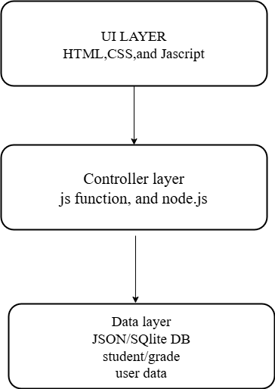
The system follows a standard Client-Server Architecture. The Client (Browser) sends HTTP requests to the Node.js/Express Server, which processes the logic and interacts with the SQLite Database.

Figure 1: Low-Level System Architecture of Student Hub
Use Case Diagram: The Use Case diagram visualizes three actors and their respective actions. Teachers can "Manage Grades" and "View Students." Students can "View Grades," "View GPA," and "Submit Feedback." The Administrator can "Manage Users," "Manage Departments," "Manage Courses," "Assign Teachers to Courses," and "Monitor Feedback Inbox." Note: The Use Case diagram requires redrawing to reflect the three-actor model.
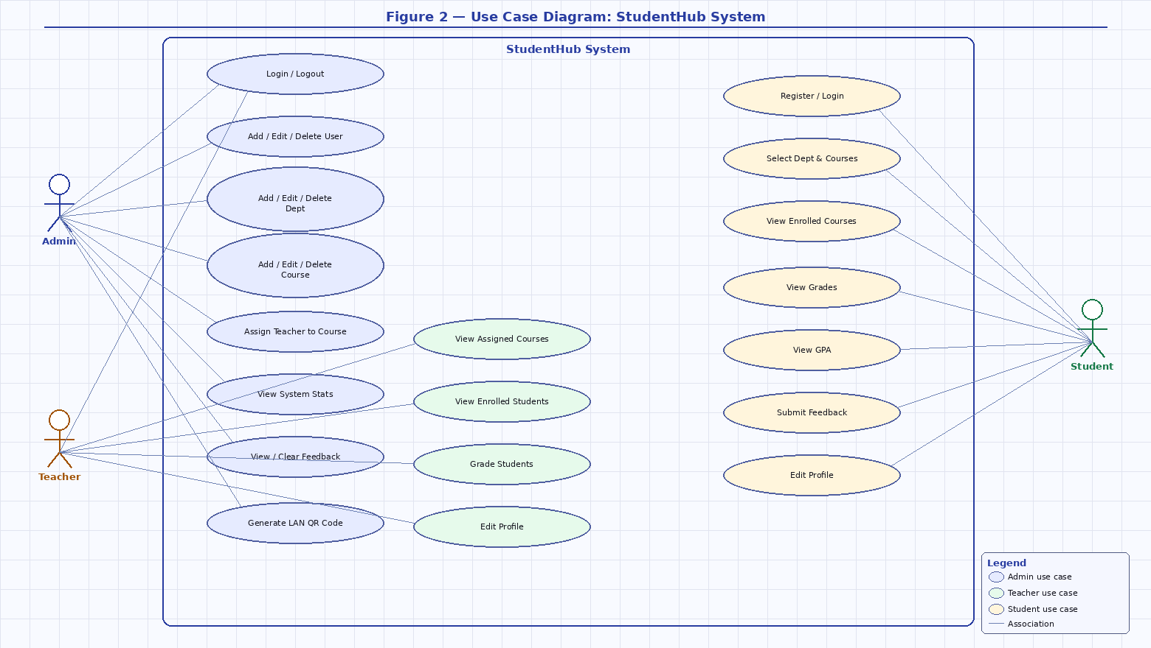
Figure 2: Use Case Diagram — StudentHub System (Admin, Teacher, Student)
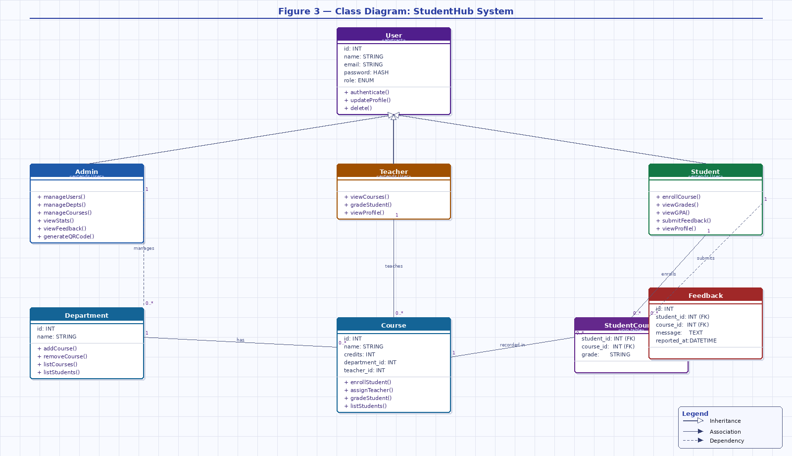
Figure 3: Class Diagram — StudentHub System (Inheritance & Associations)
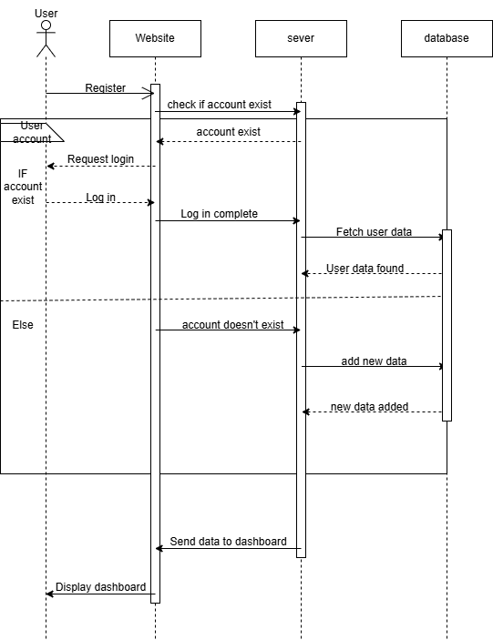
Figure 4: Sequence Diagram showing the Login and Authentication Process
4.3 Database Design
The database was implemented using SQLite. SQLite was chosen because it is serverless, requires zero configuration, and stores all data in a single .db file, making it perfectly suited for an offline, locally-hosted application. The schema was extended during development and now consists of seven tables:
Table  Name | Key Fields | Purpose
users | id, name, email, password, role | Stores all user accounts; the role field accepts 'student', 'teacher', or 'admin'
courses | id, name, credits, department_id | Stores course information and the teacher assigned to each
grades | id, student_id, course_id, grade | Links students to their respective course scores
feedback | id, student_id, course_id, message, status | Stores student grade complaints submitted via the feedback form
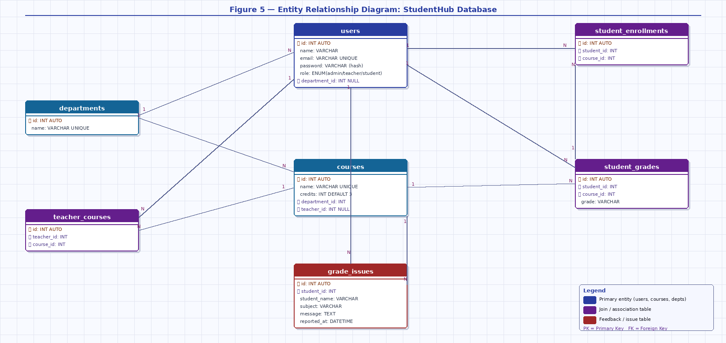
Figure 5: Entity Relationship Diagram (ERD) — StudentHub Database Schema (7 Tables)
4.4 Implementation Details
The implementation phase involved writing the code to bring the design to life. The system was developed using a well-structured MVC (Model-View-
Controller) pattern to maintain clean separation of concerns.

4.4.1 Frontend Implementation
The frontend was built using HTML5, CSS3, and vanilla JavaScript. We also used the Fetch API (Fetch API), with all dynamic data fetched asynchronously and rendered client-side. No server-side templating engine was used. The responsive design was crafted using custom CSS to ensure usability on mobile phones, tablets, and laptops alike. Three dashboards were implemented: the Student Dashboard shows grades with credit hours and a live GPA classification badge; the Teacher Dashboard supports per-course grade entry; and the Admin Dashboard provides user management, department and course CRUD operations, a searchable teacher assignment dropdown, and a QR code generator for LAN access sharing. The student signup form dynamically loads available departments and courses from the database, replacing the previous static list. UI wireframes designed in Canva served as a visual guide throughout the implementation phase.
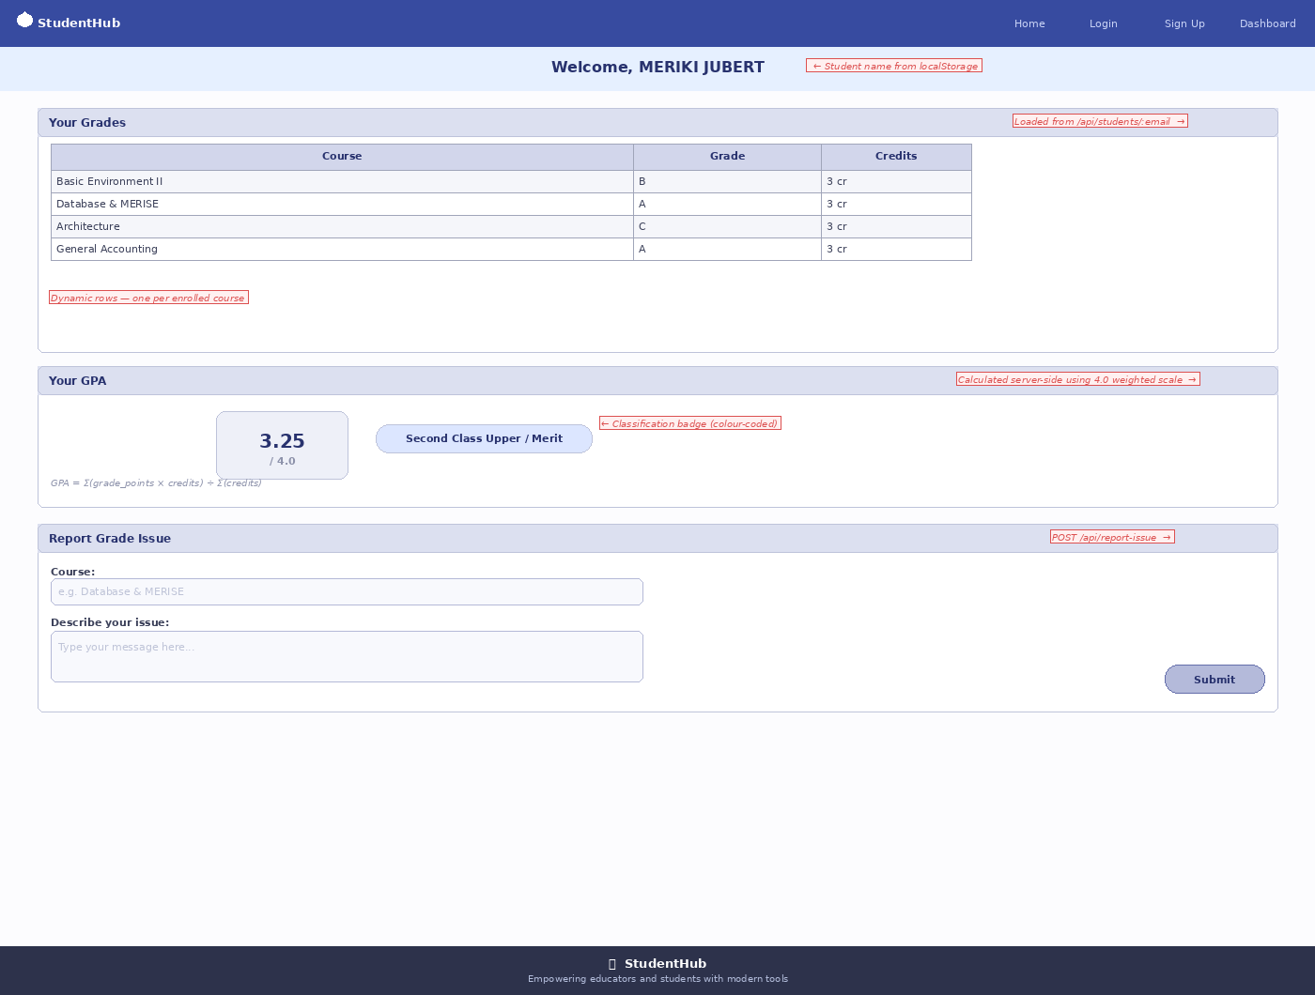
Figure 7: Student Dashboard – UI/UX Wireframe Design
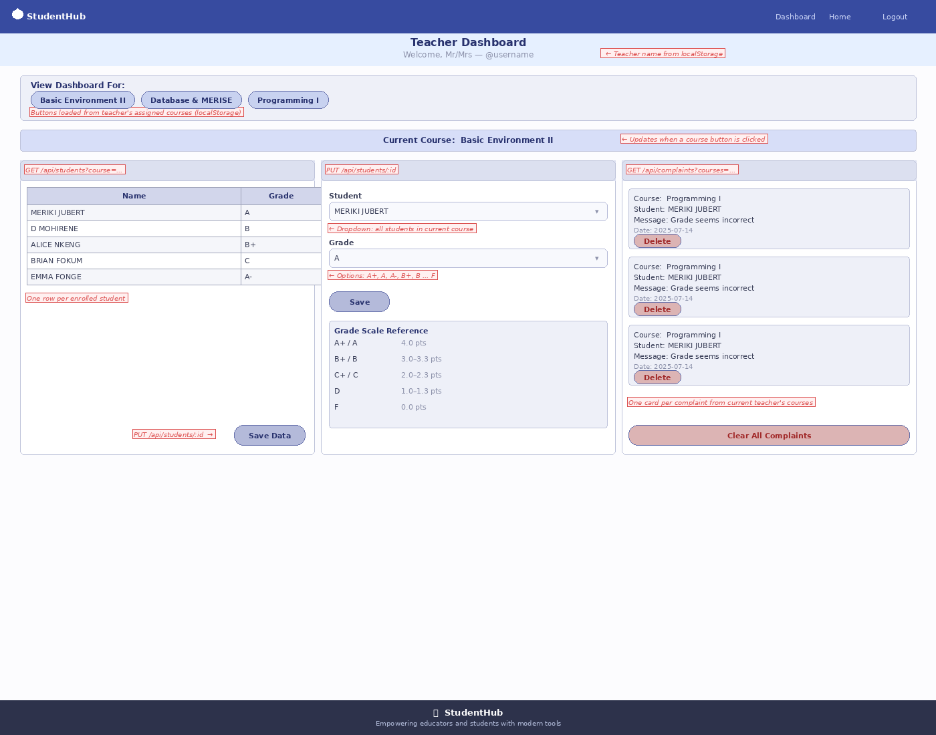
Figure 8: Teacher Dashboard – UI/UX Wireframe Design

4.4.3 Admin Dashboard Wireframe
The Admin Dashboard wireframe illustrates the full control panel available to the administrator role. It includes a LAN network banner with a dynamic QR code for device access, a hero section, four live statistic cards (total students, teachers, courses, and pending feedback), a User Management section with inline add-user form and edit/delete controls, a Course Management section with searchable teacher assignment dropdown, a Department Management section, and a Feedback Inbox table. All data is loaded dynamically from the database with no hardcoded values.
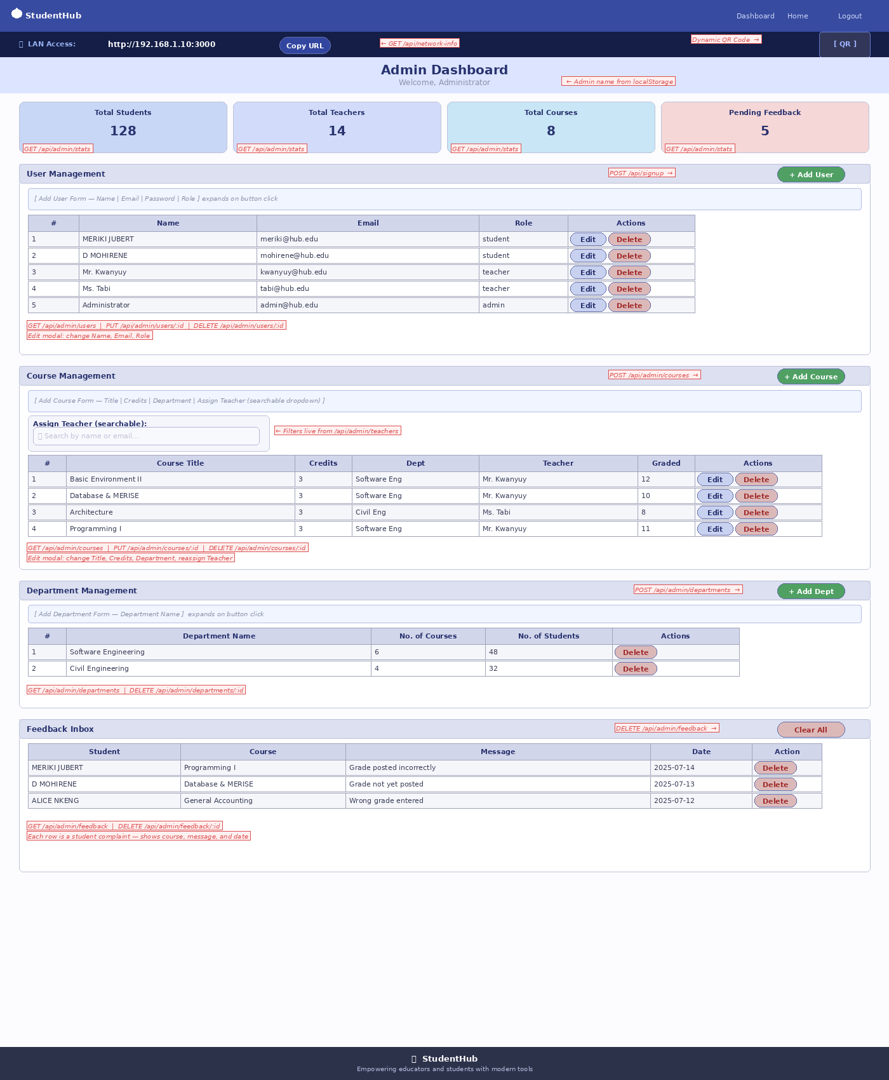
Figure 9: Admin Dashboard – UI/UX Wireframe Design

4.4.2 Backend Implementation
The backend was built with Node.js and Express.js. A clear routing structure was established with dedicated routes for authentication ( POST /api/login , POST /api/signup ), student operations ( GET /api/students/:email , /student/grades ), and teacher operations ( PUT /api/students/:id , /teacher/grades/edit ).
Session state is managed on the client side using the browser’s localStorage. Upon login the server returns the authenticated user object, which is stored in localStorage. Each dashboard performs a role check on load and redirects to the login page if the stored role does not match. Password security was handled using the b crypt (bcrypt) library to hash all passwords before storage. Passwords are stored as bcrypt hashes in the SQLite database, ensuring that plain-text credentials are never persisted at any point.
4.5 Testing and Validation
Unit Testing: Individual modules, such as the grade calculation logic, were tested to ensure accuracy.
Integration Testing: We verified that the frontend forms correctly sent data to the backend API and that the database updated accordingly.
User Acceptance Testing (UAT): Peers were invited to use the system, resulting in feedback that led to improvements in the navigation menu.

GENERAL CONCLUSION

The internship at the Digital Development Center (DDC) was a transformative experience that successfully bridged the gap between my academic coursework at SHIBMATS and the practical realities of the software engineering industry. Over the course of four weeks, I not only enhanced my technical proficiency in modern web technologies like Node.js, Express.js, and SQLite but also developed crucial soft skills such as teamwork, time management, and professional communication.
The "Student Hub" project stands as a testament to the skills acquired. It addresses a genuine problem faced by local educational institutions—the lack of affordable, digital student management systems. By delivering a functioning, locally-hosted prototype, this project demonstrates that complex problems can be solved with lightweight, efficient software architectures. The implementation of a three-tier Role-Based Access Control system — covering students, teachers, and administrators — alongside dynamic department and course management, GPA calculation weighted by credit hours, bcrypt password security, and LAN multi-device access, ensures the system is both capable and practical for real-world institutional use.
While the system currently lacks features such as student profile editing and email or SMS notifications, it has successfully addressed the initial limitation of single-device access through LAN deployment and QR code sharing. Future iterations could include attendance tracking, parent notification modules, and optional cloud synchronisation for institutions with reliable internet access.
In conclusion, this internship has confirmed my passion for software engineering and provided me with the confidence to tackle more complex challenges in my future career.

BIBLIOGRAPHY
Books & Articles:
Aliyu Musa (2019). Research on the Development of Student Grade Management Systems. International Journal of Computer Applications.
Mohammad A. Alia & Hussein A. Al Bahadili (2015). Role-Based Access
Control in Educational Information Systems. Journal of Information Security.
Okonigene, E. & Ehikioya, E. (2017). Offline-based Student Management Systems for Rural Areas. African Journal of Computing & ICT.
Technical Documentation:
Mozilla Developer Network (MDN). Express/Node.js Web Framework
(Tutorials). Available at: https://developer.mozilla.org
SQLite Documentation. SQLite Syntax and usage. Available at: https://www.sqlite.org/docs.html
W3Schools. HTML, CSS, and JavaScript Tutorials

APPENDICES
APPENDIX A: System Screenshots – Student Hub Web Application
This appendix contains screenshots of the fully implemented Student Hub web application, illustrating the login page, student dashboard (with GPA display), teacher grade management dashboard, and the admin control panel including the user management and QR code LAN sharing feature. Screenshots are to be inserted here upon final submission.
Home/LogIn/SignUp:
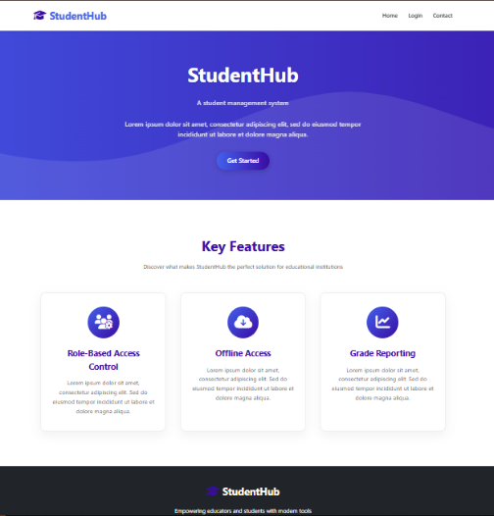
Figure 10: Homepage

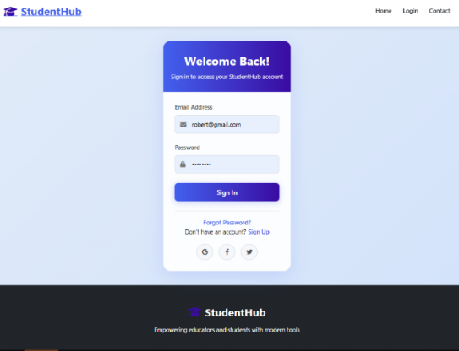
Figure 11: login page
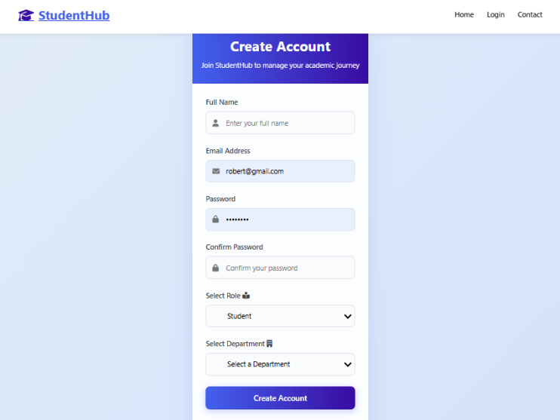
Figure 12: Signup page

Admin Dashboard:
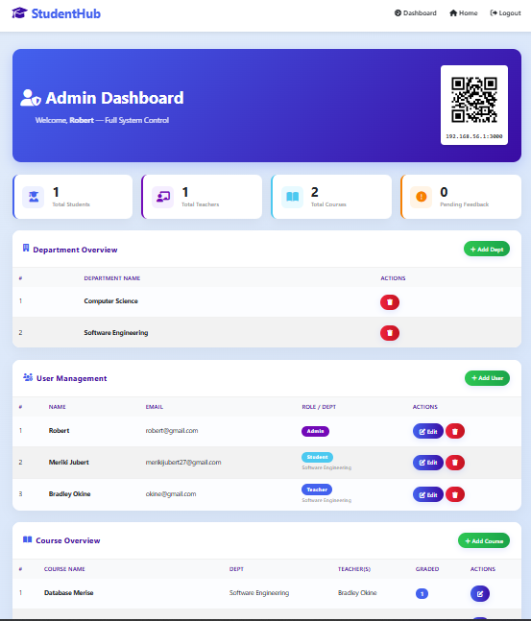
Figure 13: Admin Dashboard
Tutor Dashboard:
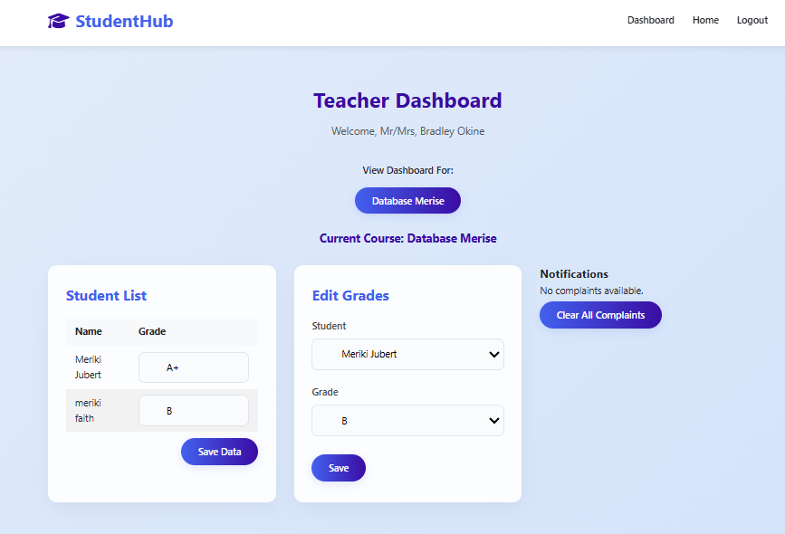
Figure 14: Teacher Dashboard
Student Dashboard:

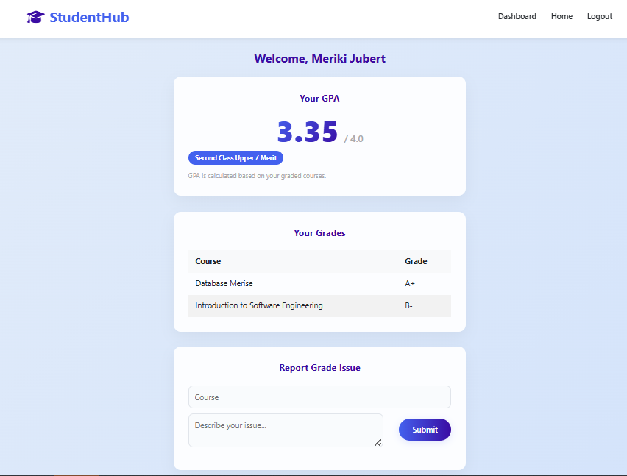
Figure 15: Student Dashboard

APPENDIX B: Internship Acceptance Letter from DDC
This appendix contains a copy of the official internship acceptance letter issued by the Digital Development Center (DDC), Buea, authorizing MERIKI JUBERT to carry out the internship from 1st February to 1st March 2025. The letter is to be attached here upon final submission.

APPENDIX C: Source Code Structure – StudentHub Project File Tree
This appendix presents the directory and file structure of the StudentHub project as organized on the development machine. The project follows an MVC architecture with clearly separated concerns across the following folders and files:
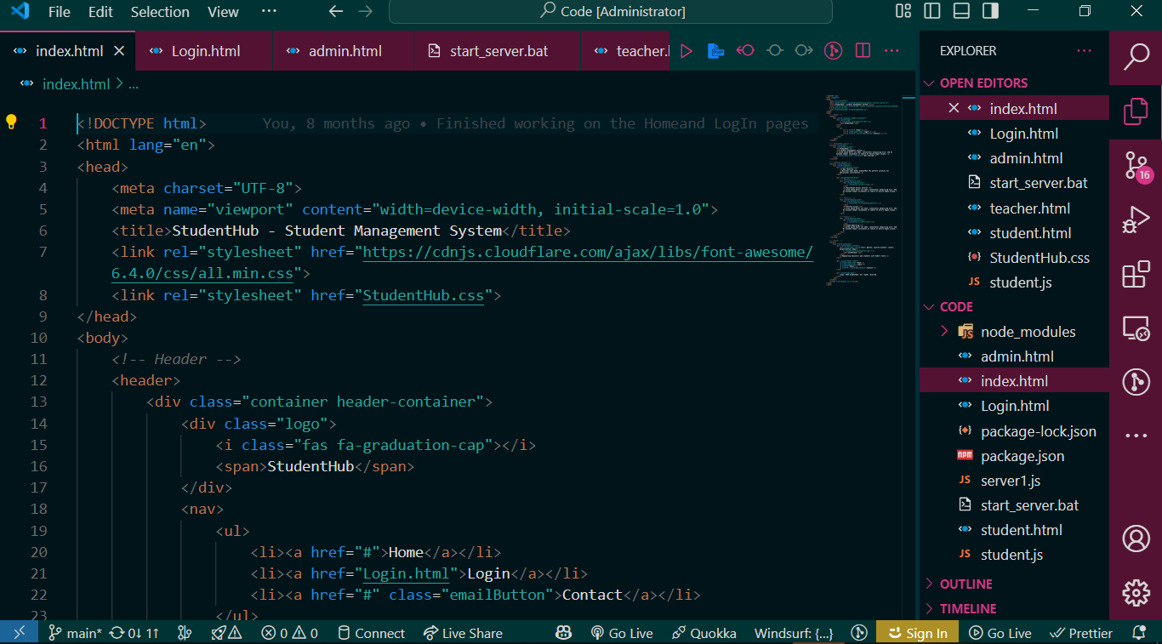
Figure 17: Codebase snapshot

